**LAB MANUAL**



**ROLLNO:AV.SC.U4CSE24121**

**NAME: RITHWIK G**

**SECTION: CSE-B**

**WEEK-1:**

**Aim:** How to install jdk and first program on

printing student details*.*

**Step-1:** Download JDK-21 from oracle website

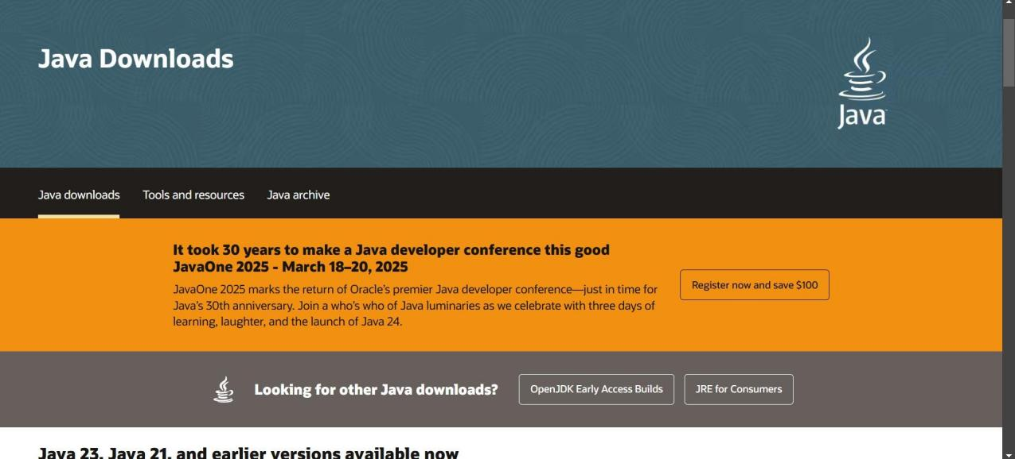

**Step-2:**Install the JDK-21 with accepting terms and

conditions according to the respective windows.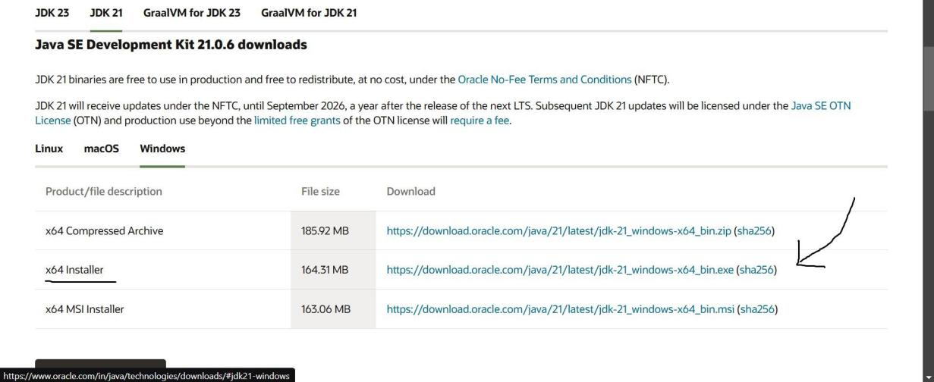

**Step-3**:Setting up environmental variables.

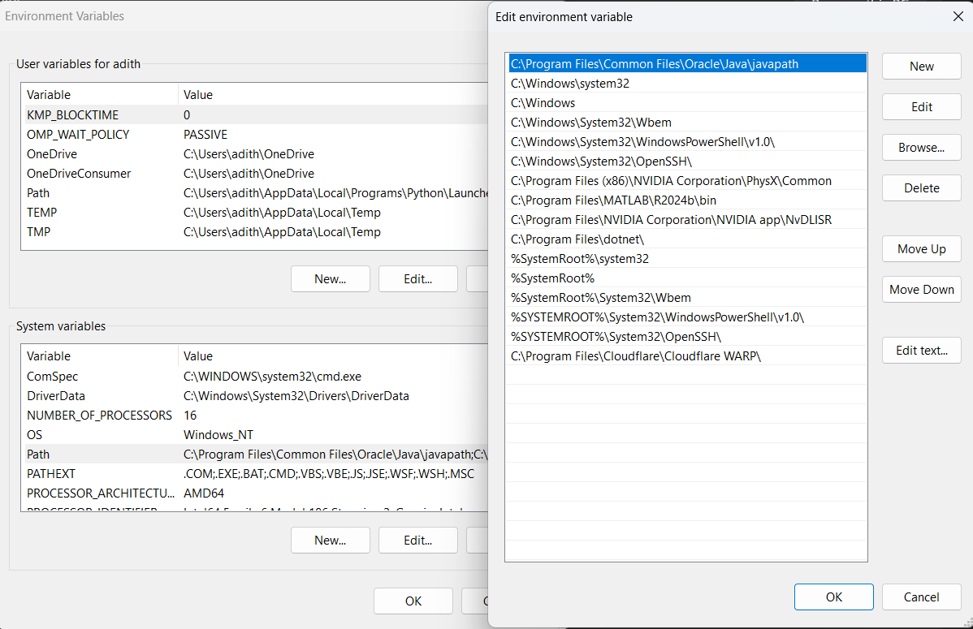

*Windows c -> C-drive -> program files ->Java -

>JDK-21->select bin

*Select and open environmental variable in search

bar-> either select system variables or user

variables-> select path-> click edit->New-> paste

the bin-> finish the setup(apply the changes).

~for verifying the installed version

Open cmd-> type java --version

~command propt

Javac filename.java ->compiling.

Java filename.java ->displaying

**PROGRAM-1(Rectified):**

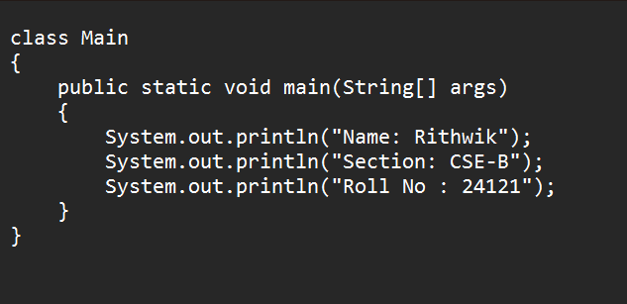

**Output:**

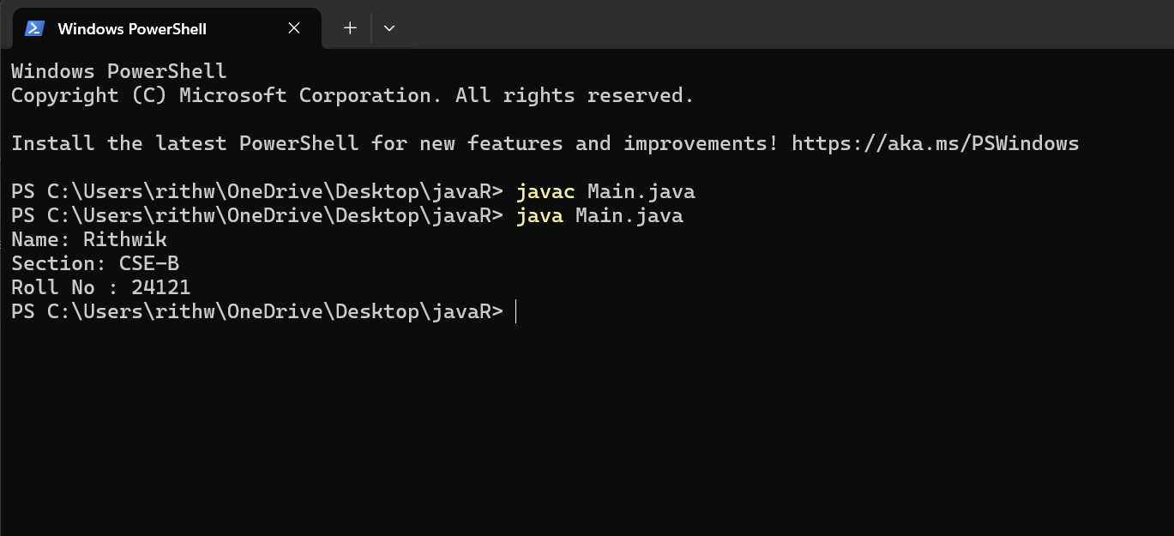

***IMPORTANT POINTS:***

1. ***When printing the statements, everything should be inside double quotes.***

**WEEK-2:**

**PROGRAM-1:**

**Aim:**Write a java program for SI

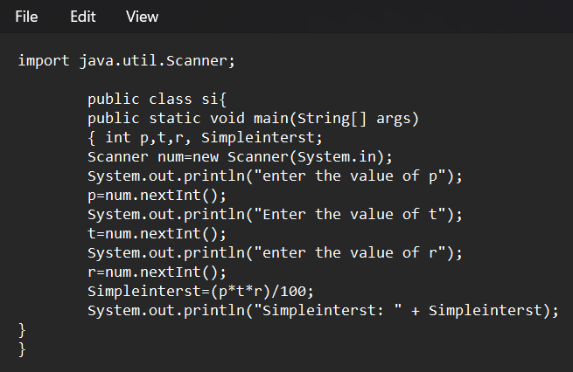

**Output:**

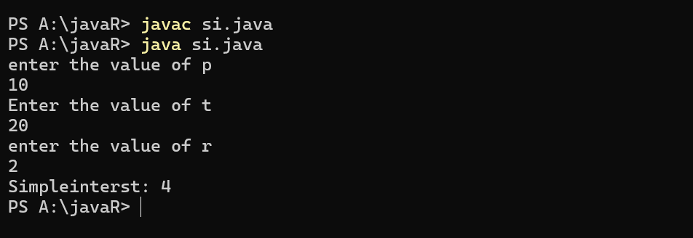

**ERROR TABLE*:***

|  |  |
| --- | --- |
| **Code Error** | **Code rectification** |
| 1.Giving space between next and Double.  2.Not giving parenthesis after closing the input. | 1.Should not give space between next and Double.  2.We must put parenthesis after closing the input. |

***IMPORTANT POINTS:***

1. ***Simple interest formula is: (p*t*r)/100, where:***

***P: Principal amount***

***R: Rate of interest***

***T: Time period***

1. ***The data type double indicates the floating points in the integers.***
2. ***The line “import java.util.Scanner” indicates:***

***Import: tells the java compiler that we want to use a specific class or package in your code.***

***Java.util : This is the package that contains utility classes for Java programming, including the “Scanner” class.***

***Scanner: this is the class that allows you to read input from the keyboard.***

**PROGRAM-2:**

**Aim:**Write a program in java for area of

rectangle.

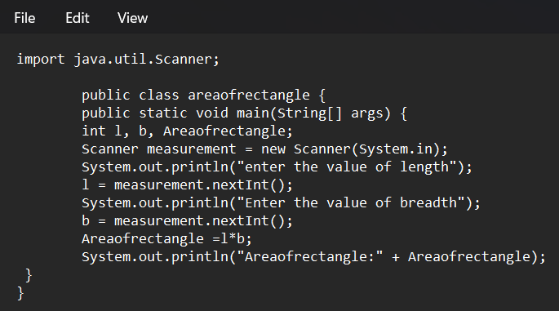

**Output:**

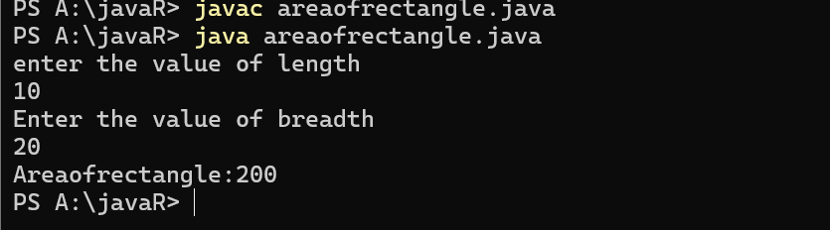

**ERROR TABLE:**

|  |  |
| --- | --- |
| **Code Error** | **Code rectification** |
| 1.While using for iteration, not giving the conditions correctly.  2.Declaring the data type as double instead of int. | 1.We should give iterative statements correctly.  2.We should give the data type as int for integers. |

IMPORTANT POINTS:

1. Area of a rectangle is area = l*b, where

L = length of a side of the rectangle,

B= breadth of a side of the rectangle.

1. Here, we must be sure that all the expressions/conditions inside for the for loop must be given correctly.

**PROGRAM-3:**

**Aim:**Write a program in java for area of triangle using heron’s formula.

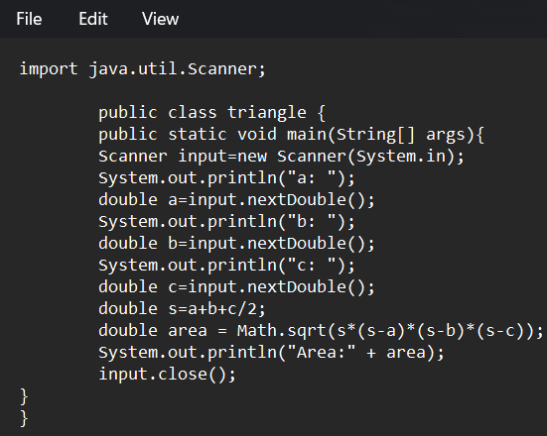

**Output:**

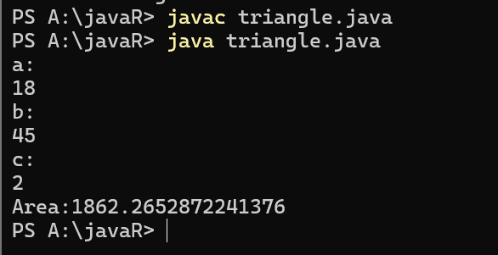

ERROR TABLE:

|  |  |
| --- | --- |
| **Code Error** | Code rectification |
| 1.While printing the variable not giving + sign.  2.Not closing the scanner. | 1.We should give correct indentation.  2.Closing the scanner is must. |

**PROGRAM-4(a):**

**Aim:**Write a program in java for converting temperature from celsius to fahrenite.

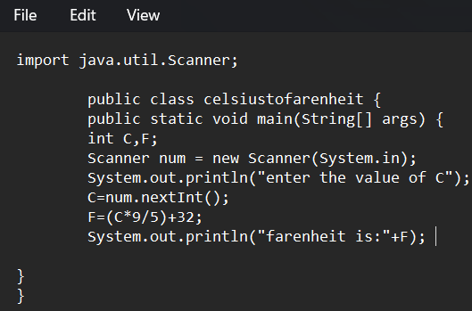

OUTPUT:

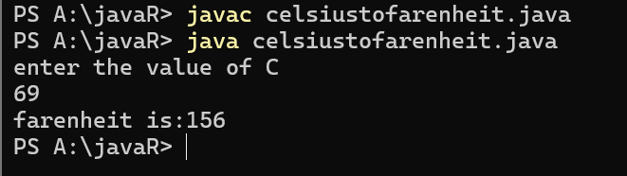

**PROGRAM-4(b):**

**Aim:**Write a program in java for converting temperature from fahrenite to celsius.

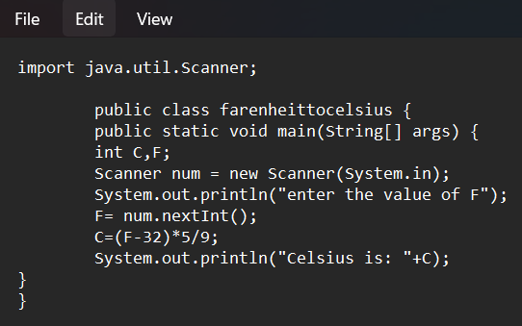

**Output:**

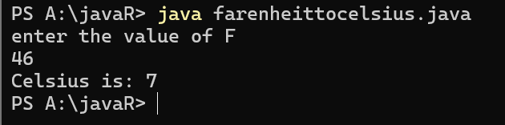

**ERROR TABLE:**

|  |  |
| --- | --- |
| **Code Error** | **Code rectification** |
| 1.While printing the variable not giving + sign.  2.Not closing the scanner. | 1.We should give correct indentation.  2.Closing the scanner is must. |

IMPORTANT POINTS:

1. Area of a rectangle is area = l*b, where

L = length of a side of the rectangle,

B= breadth of a side of the rectangle.

1. Here, we must be sure that all the expressions/conditions inside for the for loop must be given correctly.

**PROGRAM-5:**

**Aim:**Write a program in java for factorial of a number.

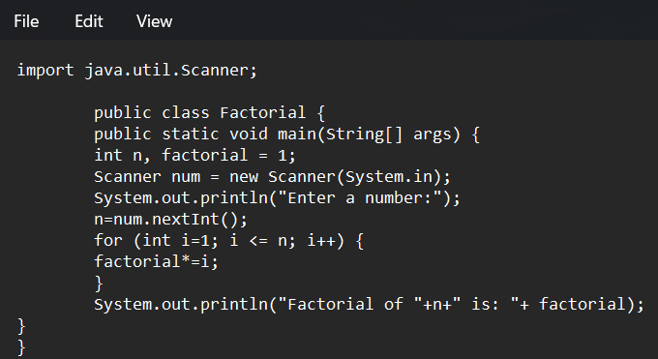

OUTPUT:

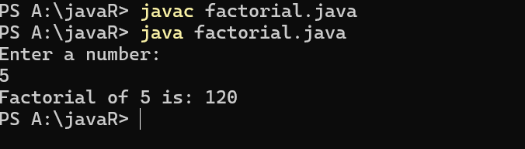

IMPORTANT POINTS:

1. While the for loop the data inside the parenthesis indicates the Initial expression

Test expression and

Update expression.

1. Here “factorial*=I” means factorial = factorial*I.
2. Here we are using the data type “int” just to calculate the integer values and it doesn’t support floating points.

ERROR TABLE:

|  |  |
| --- | --- |
| **Code Error** | **Code rectification** |
| 1.While using for iteration, not giving the conditions correctly.  2.Declaring the data type as double instead of int. | 1.We should give iterative statements correctly.  2.We should give the data type as int for integers. |

**PROGRAM-6:**

**Aim:**Write a program in java for fibonacci series.

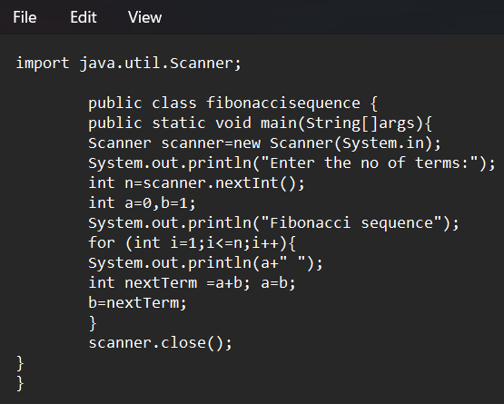

OUTPUT:

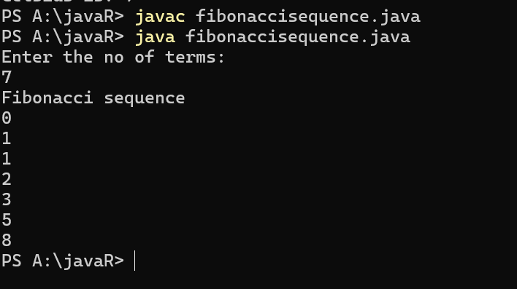

ERROR TABLE:

|  |  |
| --- | --- |
| **Code Error** | **Code rectification** |
| 1.Giving space between next and Double.  2.Not giving parenthesis after closing the input. | 1.Should not give space between next and Double.  2.We must put parenthesis after closing the input. |

**WEEK -3:**

**PROGRAM-1:**

**AIM:** To create java program with following instructions :

1.Create a class with name Car

2.Create four attributes named car_color,car_brand, fuel_type, mileage

3.Create these methods named start(),stop(),service()

4.Create the objects named car, car1,car2

**CODE:**

public class Car {

private String car_color;

private String car_brand;

private String fuel_type;

private String mileage;

public void start() {

System.out.println("car is started");

}

public void stop() {

System.out.println("car is stopped");

}

public void service() {

System.out.println("car is for service");

}

public static void main(String args[]) {

Car car = new Car();

car.car_color = "white";

car.car_brand = "audi";

car.fuel_type = "petrol";

car.mileage = "20";

car.start();

System.out.println("car_color: " + car.car_color + " car_brand: " + car.car_brand + " fuel_type: " + car.fuel_type + " mileage: " + car.mileage);

Car car1 = new Car();

car1.car_color = "white";

car1.car_brand = "audi";

car1.fuel_type = "petrol";

car1.mileage = "20";

car1.stop();

System.out.println("car_color: " + car1.car_color + " car_brand: " + car1.car_brand + " fuel_type: " + car1.fuel_type + " mileage: " + car1.mileage);

Car car2 = new Car();

car2.car_color = "white";

car2.car_brand = "audi";

car2.fuel_type = "petrol";

car2.mileage = "20";

car2.service();

System.out.println("car_color: " + car2.car_color + " car_brand: " + car2.car_brand + " fuel_type: " + car2.fuel_type + " mileage: " + car2.mileage);

}

}

**OUTPUT:**

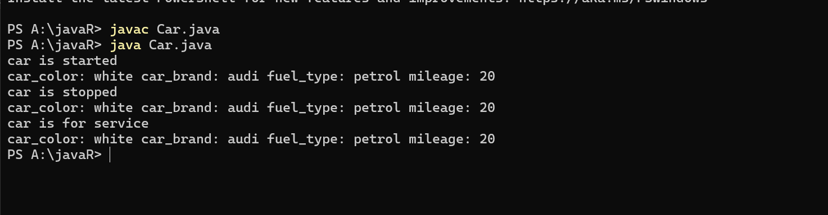

**Error table:**

|  |  |  |  |
| --- | --- | --- | --- |
| S.no | Error name | Cause of error | Rectification |
| 1 | Syntax Error | Missing ‘{‘ | ‘{‘ added |
| 2 | Compile time Error | Mispelled Variable call | Rectified with  Correct variable name |
| 3 | Case sensitive error | Uppercase and lowercase | rectified |

**Class diagram:**

|  |
| --- |
| **car**  **----------------------**-  -car_color:string  -car_brand:string  -fuel_type:string  -milage:double  ----------------------  +start():void  +stop():void  +service():void |

IMPORTANT POINTS:

1. Before calling the function we should write the method properly.
2. Here, the “public void start( )” indicates that we are writing a method to call the function.
3. When we call a certain method, the process inside it will be printed as an output of the code.
4. Here the details inside the function are called objects, we can give any objects

**PROGRAM-2:**

**Aim:** To create a class BankAccount with methods deposit() and withdraw() . create two subclasses savingsaccount and checkingaccount override the withdraw () method in each subclass to impose different withdrawal limits and fees

public class BankAccount {

protected String accountHolder;

protected double balance;

protected int accountNumber;

public BankAccount(String accountHolder, int accountNumber, double balance) {

this.accountHolder = accountHolder;

this.accountNumber = accountNumber;

this.balance = balance;

}

public void withdrawal(double amount) {

if (amount <= balance) {

balance = balance - amount;

System.out.println("Current balance: " + balance);

} else {

System.out.println("Insufficient funds");

}

}

public void deposit(double amount) {

balance = balance + amount;

System.out.println("Current balance: " + balance);

}

public static void main(String[] args) {

BankAccount BA = new BankAccount("Abdul", 24248, 1000);

BA.withdrawal(500);

BA.deposit(1500);

}

}

**OUTPUT:**

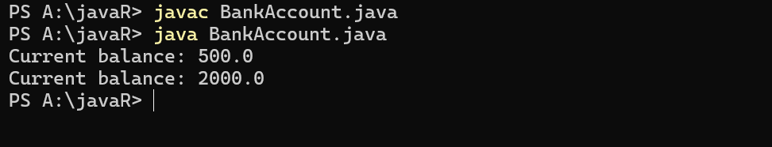

**Error table:**

|  |  |  |  |
| --- | --- | --- | --- |
| S.no | Error name | Error name | Rectification |
| 1 | Name Error | Undefined name | Correct variable  Name replaced |
| 2 | Syntax Error | Missing Parenthesis | Parenthesis Added |
| 3 | Logical Error | Incorrect Condition | Condition Rectified |

**Class diagram:**

|  |
| --- |
| **BankAccount**  ----------------------------------------------------------  -balance: double  ----------------------------------------------------------  +BankAccount(intialBalance: double)  +deposit(amount: double):void  +withdraw(amount: double):void |

IMPORTANT POINTS:

1. The condition inside the if statement must be correct.
2. It explains that if the withdrawal money is less than the money in the bank account, then we can withdraw the amount.

WEEK -4

PROGRAM – 1:

AIM: Write a java program with class named “book”, the class should contain various attributes such as title, author, year of publication it should also contain a constructor with parameters which initializes, title, author, and year of publication.

Create a method which displays the details of the book and display the details of two books.

CODE:

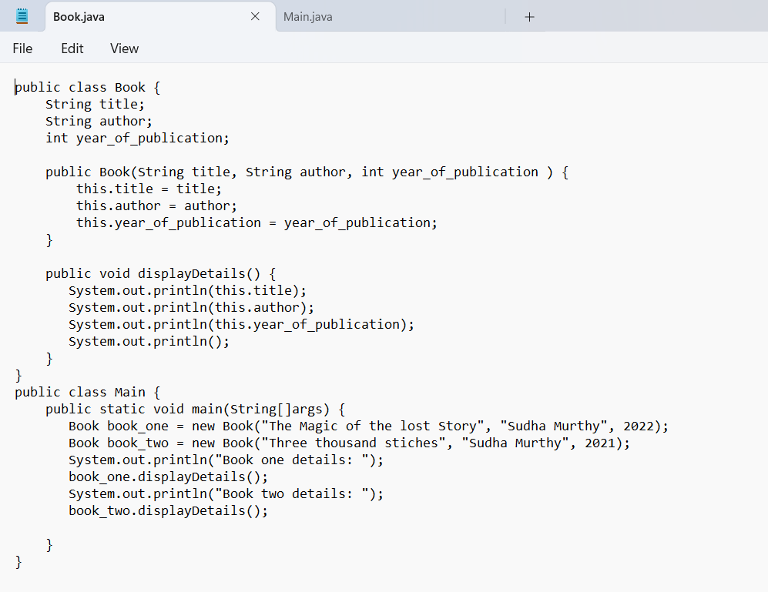

OUTPUT:

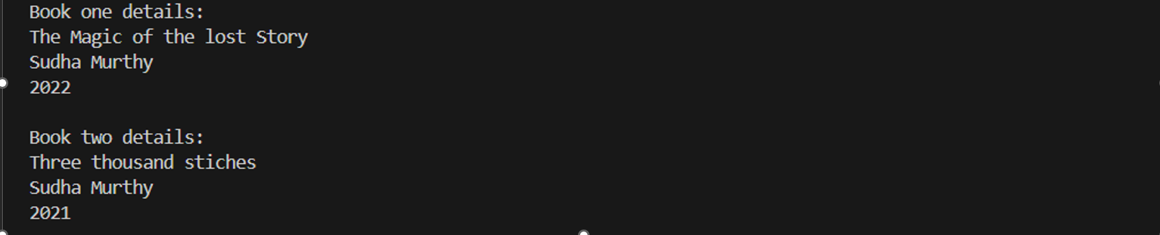

ERROR TABLE:

|  |  |
| --- | --- |
| **Code Error** | **Code rectification** |
| 1. Not defining the function in a file. 2. Two public class files should not be saved in the same file. | 1. To call the method we must define a function in a file. 2. Two public class files should be saved in different files. |

IMPORTANT POINTS:

1. While defining two classes for a code, we must be sure that we save both the classes in separate files.
2. While defining a method we should also define a function to call that method.

CLASS DIAGRAM:

|  |
| --- |
| Book   * Title: String * Author: String * Year of publication: int   + Book(title: String,  Author: String;  Year of publication: int  + displayDetails( ): void |

PROGRAM – 2:

AIM: Create a java Program with class named myclass with static variable count of int type, initialized to zero and a constant variable “pi” of type double initialized to 3.14 as attributes of the class, ow define a constructor for “myclass” that increments the count variable each time an object of my class is created (count++), finally print the final values of count and pi variables create three objects.

CODE:

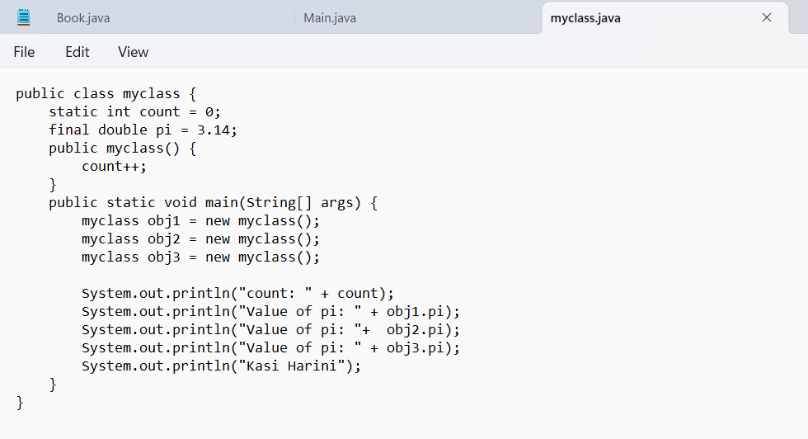

OUTPUT:

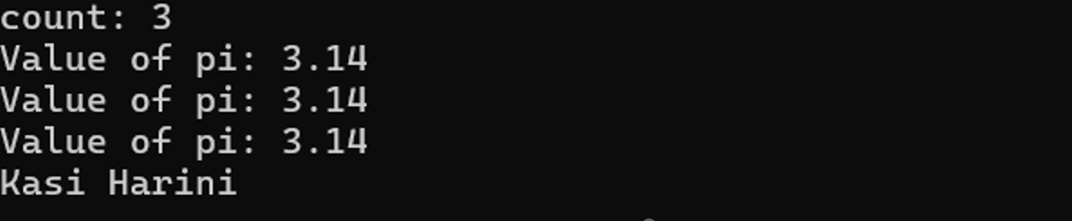

ERROR TABLE:

|  |  |
| --- | --- |
| **Code Error** | **Code rectification** |
| 1. Not Putting the semi-colon after calling a function, 2. Not giving the indentation properly. | 1. Put the semi-colon after calling a function. 2. All the indentation must be correct to run the code correct. |

IMPORTANT POINTS:

1. We must declare the initial value of the variable before declaring the final one.
2. Here the main objective is to increase the count according to the number of objects we make, i.e the count increases when the no.of objects are increasing.

CLASS DIAGRAM:

|  |
| --- |
| Myclass   * Count: int * Pi: double   + myclass( )  + main(args: String[]): void |